Liquid Flow Controller/Meter
Operating Instructions

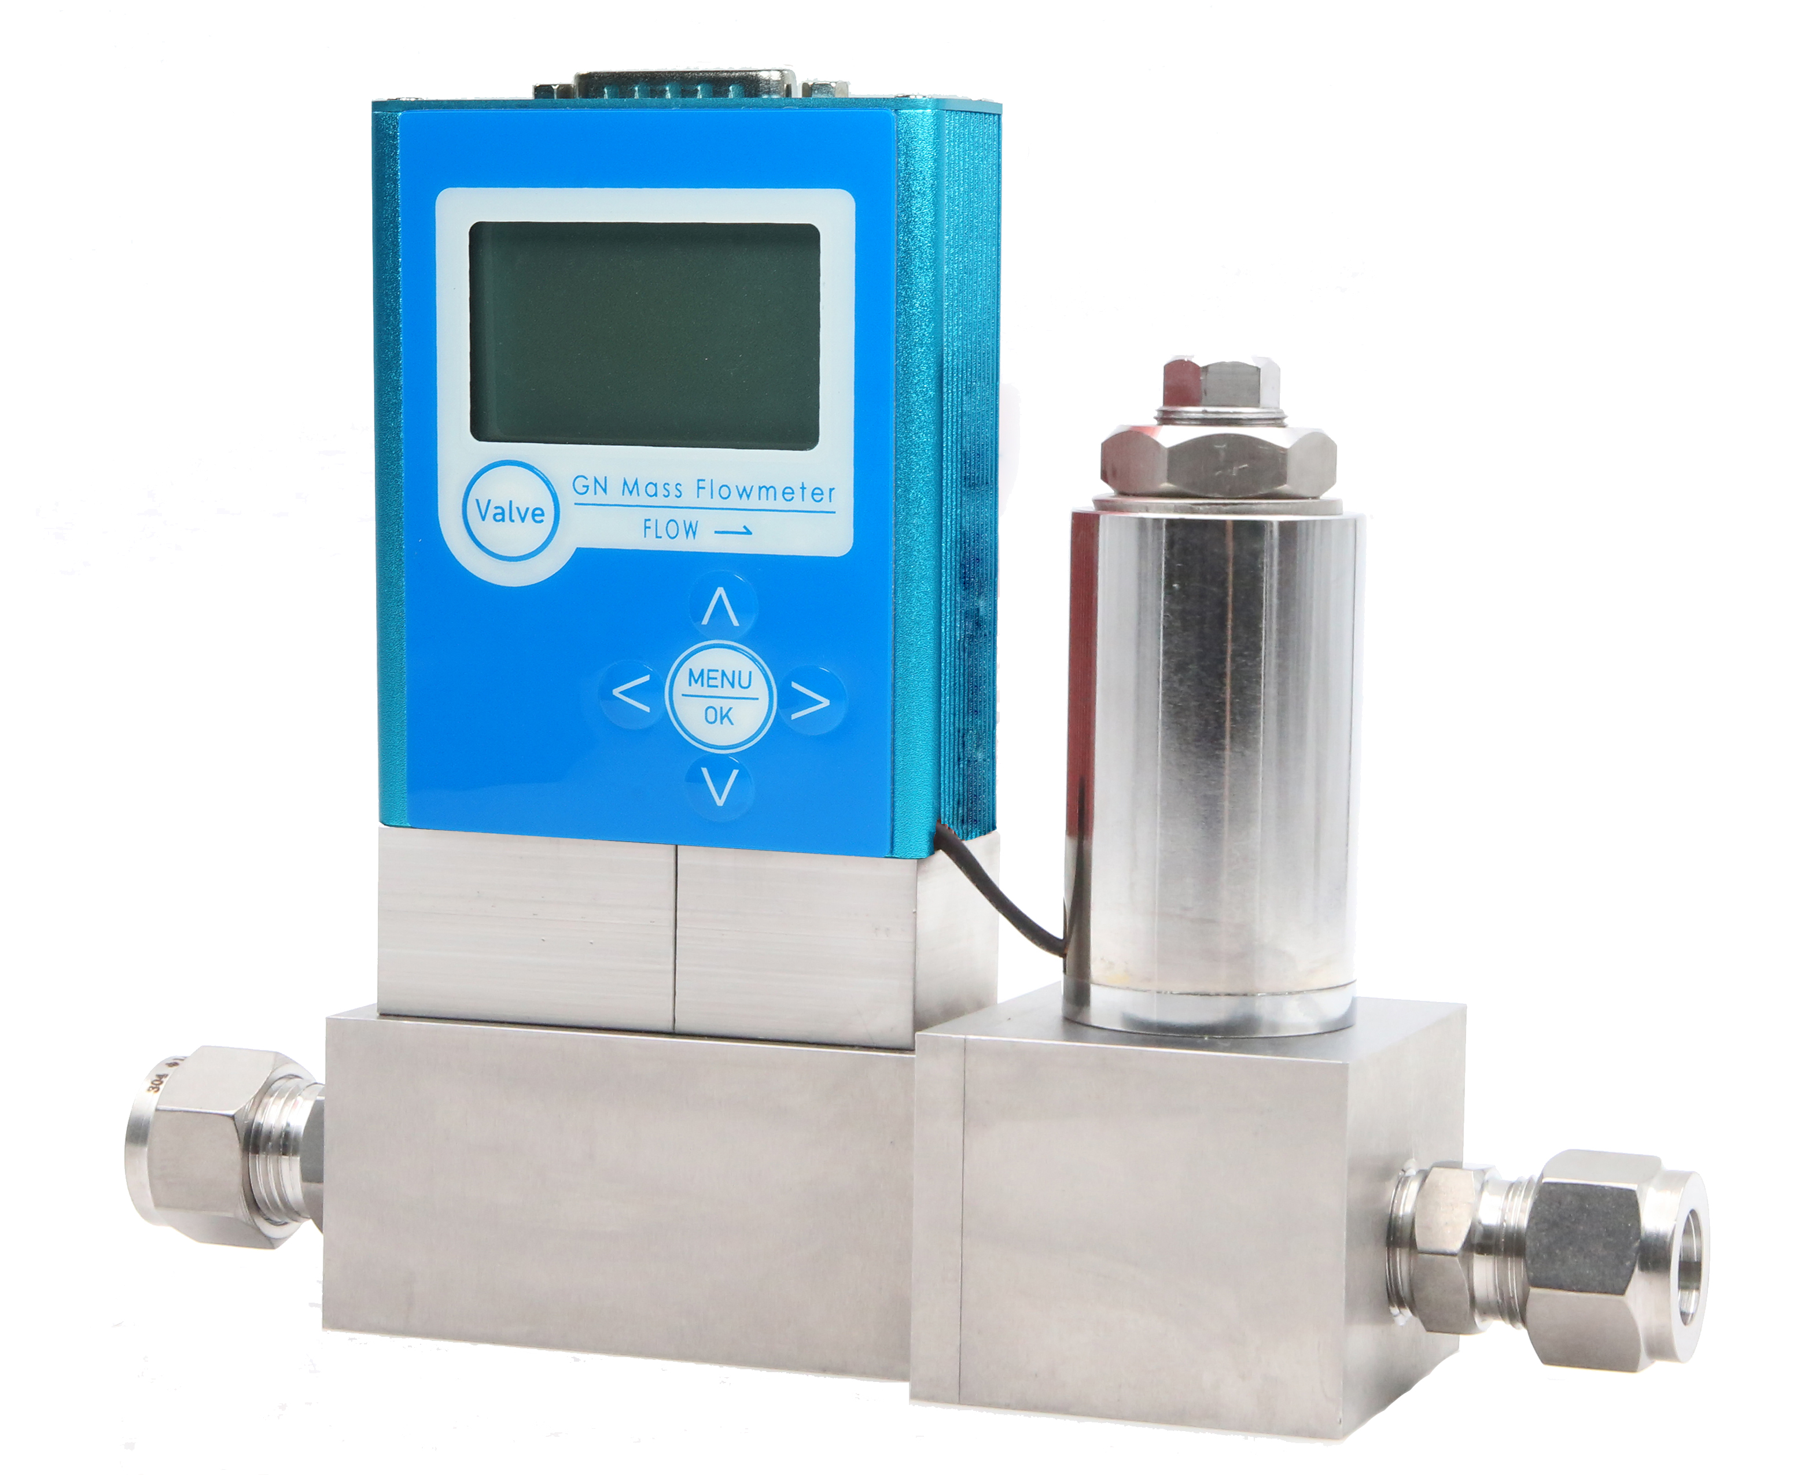

Product description

1.1 Uses and features

The liquid flow controller has a liquid flow measurement function and can accept the computer to set the flow value and adjust it by PID.

Control the regulating valve to automatically complete the flow adjustment. Flow controller has small size, high integration, high accuracy, and adjustment time

Small, easy to use, stable work, etc., according to different media, need to have explosion-proof function.

The liquid mass flow controller is capable of collecting liquid flow from the pipeline and is capable of accepting computer settings via PID

The program controls the regulating valve to complete the automatic adjustment of the flow. The flow controller has small volume, high integration and high accuracy.

The adjustment time is small, the use is convenient, and the work is stable.

1.2 Main Specifications
1 | Flow range: | 0-20L/min
2 | Accuracy | ±0.3%-2%F.S
3 | Linearity | ±0.2~0.3%F.S
4 | Repeatability | ±0.2%F.S
5 | Responding time | Electrical characteristics:10sec gas characteristics：（1~4）sec
6 | Differential pressure range | 0.1~0.5MPa
7 | Max pressure | 1MPa
8 | Working temperature | 0~70℃
9 | Digital value | RS485 MODBUS
10 | Analog value | DC 0~5V ，4~20mA
11 | Power supply | DC +15V/24V，flow meter＜400mA，flow controller＜600mA
12 | Electrical connection | DB15
13 | Leakage rate | 1×10⁻⁸SCCSHe
14 | Material of base | 316L Stainless steel
15 | Seal material | FKM，nitrile butadiene rubber，chloroprene rubber
16 | Glad hand | M18*1.5
note:
The mass flow meter and mass flow controller are usually calibrated with H2O.
The unit of mass flow is stipulated as: L/H
Standard state stipulates: temperature -----273.15K (0℃);
Pressure -----101325 Pa(760mm Hg）
F.S (Full Scale); Full-scale value

1.3 Working principle
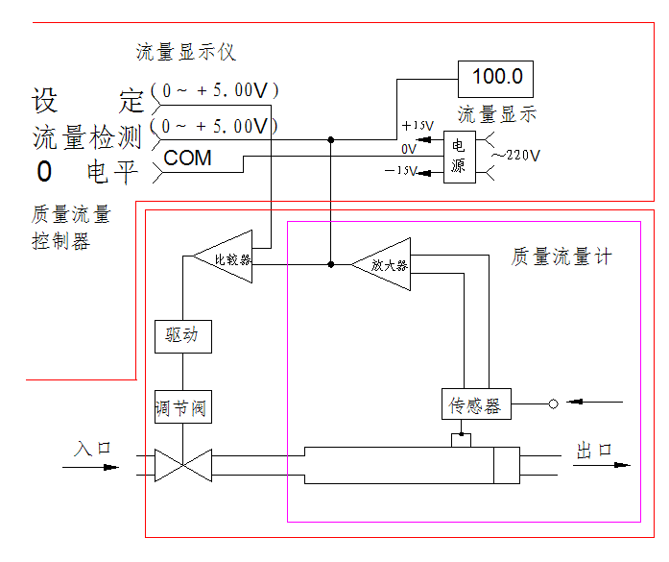

Picture(3)Working principle diagram

II. Quick installation guidance

2.1 Shape and installation dimensions
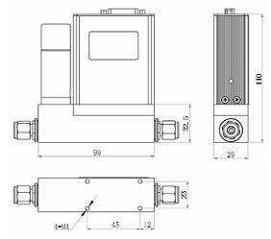
图三、CX Dimensions of mass flow controller

2.2 Form of gladhand
nut
Back Ferrule
Front ferrule
splice
stack
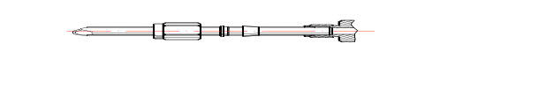

Picture(4)Installation diagram of double ferrule splice

As shown in picture 4, when installing the splice, after installing the front ferrule, back ferrule, and nut, tighten the nut and the splice by hand, then tighten with a wrench (The imported Swagelok splice requires a 1.25-turn wrench to tighten.) to ensure air tightness. Note that double wrench should be used, with one wrench stuck in the joint and the other to turn the nut. Especially when removing the nozzle, double wrench must be used, otherwise it will cause loosening of the joint and affect the sealing.

2.3 Cable connection plug
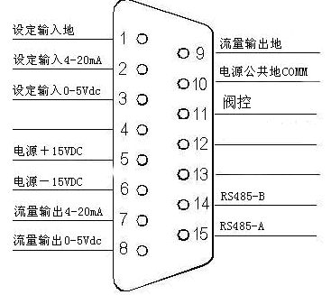

Picture(5) ±15VDC Power supply diagram

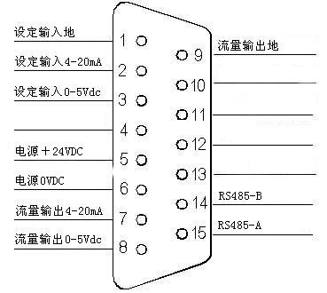

Picture(6) 24VDC Power supply diagram

III. Functional operation details

3.1 Review
The CX series flow meter uses a backlight lattice liquid crystal display, which clearly displays a variety of useful flow data, including instantaneous flow, accumulative flow, temperature, etc. CX has different display screen, it depends on the type of the order, such as flow meter or controller, current output or voltage output. The entire CX series has a unified main display screen, gas selection screen (which may be invalid when certain gases are present), calibration screen, device information, etc.
In the state of the main screen condition, press the [MENU] button on the lower right corner of the flow meter to switch the display screen to the menu screen.

3.2 Common operation
Interface specification

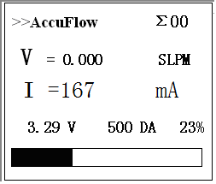
picture 1 Monitoring value display status.

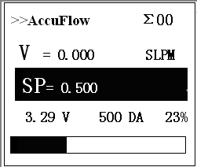
Picture 2 Valve control setting status
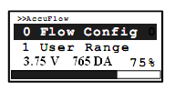
Picture 3 Menu display status

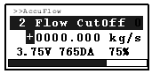
Picture 4 Parameter input dialog box
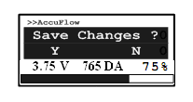
Picture 5 Storage inquiry dialog box

The function of the keys in different display situations:
[Monitoring value display status]：
Press [Left] key to switch current display parameters in sequence: instantaneous flow, current, medium temperature, accumulated flow, etc.
Press the [Right] key to reverse the current display parameters in order: cumulative flow, medium temperature, current, instantaneous flow, etc.
Press [MENU/OK] to enter the MENU display status.
[Menu display status]：
Press the [Right] key to switch the menu items of the current menu in sequence.
Press [left] key to return to the previous menu.
Press the [MENU/OK ]key to enter the next menu or the parameter input dialog box].
[Parameter input dialog box]：
Press 【Up】key to increase the number by 1
Press the [Down] key , the number to decrease by 1.
Press [Right] the cursor move one digit to the right.
Press [Left] the cursor move one digit to left.
Press [MENU/OK] key to confirm
[Storage inquiry dialog box]：
Press [right] key, do not store data or options, go back to the menu item previous [Storage inquiry dialog box].
Press the [left] key to store data or options, go back to the menu item previous [Storage inquiry dialog box].

3.3 Functional operation details

3.3.1 flow setting ：

Press [VALVE] key to enter the flow setting interface

Press [Up]key to increase flow setting, press [Down]key to decrease flow setting, press [Left] key to set flow to 0, press [Right] key to set the flow to full scale. Press the [VALVE] key to save and return monitor status.

3.3.2 Start/stop flow accumulation：
（1）Under [Monitoring value display status] Status, press [MENU/OK] to enter [Menu display status]

（2）Press the [MENU/OK] key shows that enter submenu of Usage Flow Setting
If the cumulative function is stopped, the following screen is displayed.
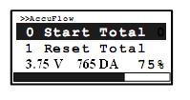
If the cumulative flow meter has been started, the following screen is displayed
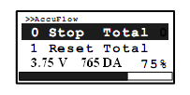
At present, press the [MENU/OK] key to enter the [Storage inquiry dialog box]
At this point, press the [Left] key to modify and store. Press the [right] key to exit to the previous menu.

3.3.3 Clear flow accumulative value
（1）Under [Monitoring value display status] Status, press [MENU/OK]key to enter [Menu display status]

（2）Press [MENU/OK]key to enter the flow setting submenu, press [right] key to make the menu item “1 Reset Total” in focus;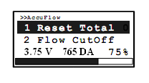
（3）Press the [MENU/OK] key to display that into the [Storage inquiry dialog box]
（4）Press [Left] key to modify and store. Press [Right] to exit to the previous menu

3.3.4 Small flow signal removal
（1）Under [Monitoring value display status] Status, press [MENU/OK] to enter [Menu display status]
（2）Press [MENU/OK]key to enter the flow setting submenu, press [right] to make the menu item “2 Flow Cut Off” in focus;
（3）Press [MENU/OK] key to enter the [Parameter input dialog box], then input the required data

（4）After modifying the last character, press the [MENU/OK] key to enter the [Menu display status]
At this point, press the [Left] key to store the data and press the [Right] key to give up storage and return to the previous menu.

3.3.5 flow coefficient:
（1）Under [Monitoring value display status]Status, press [MENU/OK]key to enter [Menu Display Status].
（2）Press the [MENU/OK] key to display that enter the flow settings submenu, press the [Left] key to make the "3 Coefficient" in the focus state
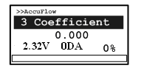
（3）Press [MENU/OK] key to enter the [Parameter input dialog box], then input the required data
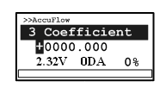
（4）After modifying the last character, press the [MENU/OK] key to enter the [Storage inquiry dialog box]

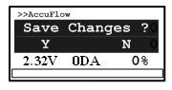

At this point, press the [Left] key to store the data and press the [Right] key to give up storage and return to the previous menu.

3.3.6 Zero setting of flow
（1）Under [Monitoring value display status]Status, press [MENU/OK]key to enter [Menu Display Status].

（2）Press [Right]key to make the menu item “2 Zero Offset” in focus;

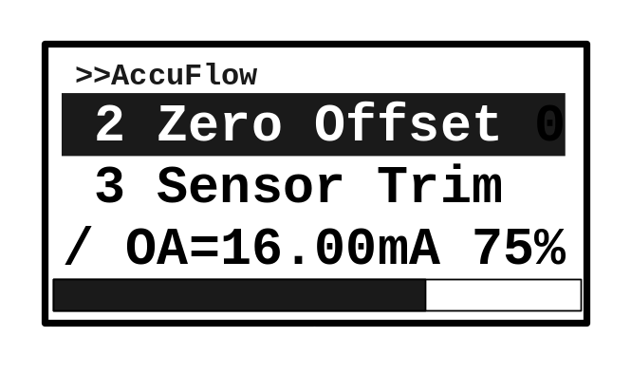

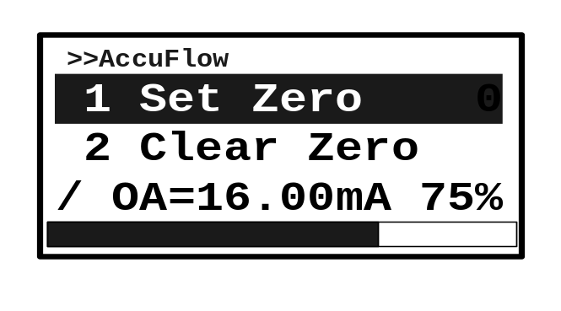（3）Press [MENU/OK] key to display the zero setting submenu of the installation position; make the menu item “1 Set Zero” in focus; press the [MENU/OK] key to perform (5) operation to set up the zero point of the flow;

（4）Press the [Right] key to make the menu item “2 Clear Zero” in focus; this is the operation to cancel set zero of flow;

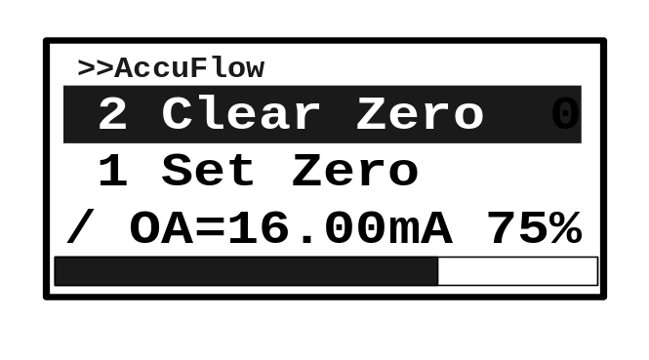

（5）Press [MENU/OK] to display enter the [Storage inquiry dialog box]

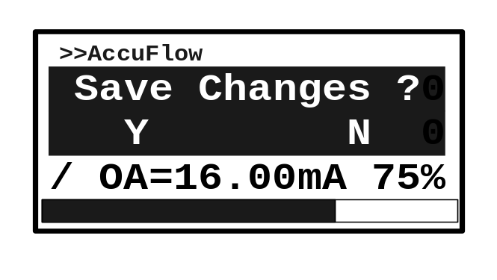

At this point, press the [Left] key to store the zero value, and press the [Right] key to give up storage and return to the previous menu.

3.3.7 Device polling address setting:

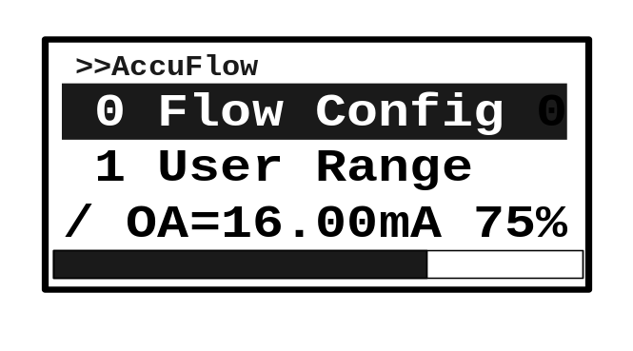（1））Under [Monitoring value display status]Status, press [MENU/OK] to enter [Menu Display Status].

（2）Press [right]key to make the menu item "6 Hart Address" in the focus state
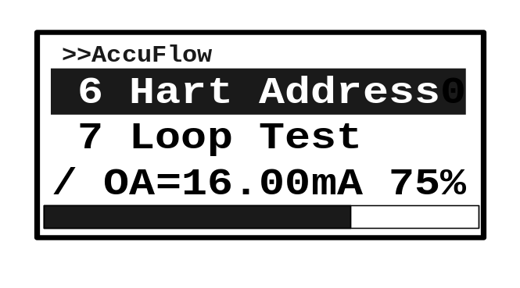

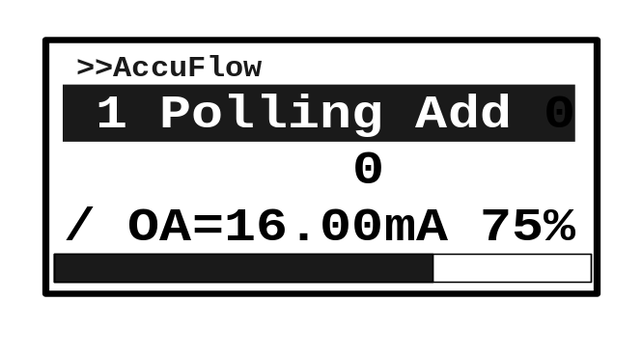（3）Press [MENU/OK] key to enter the Hart address setting submenu. The third line shows the current polling address.

（4）Press [MENU/OK] key to enter the [Parameter input dialog box] and enter the expected value (address range 0~31).
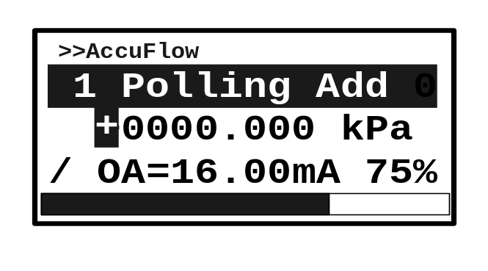

（5）After modifying the last character, press the [MENU/OK] key to enter the [Storage inquiry dialog box]

At this point, press the [Left] key to store the data and press the [Right] key to give up storage and return to the previous menu.

3.3.8 Loop output test:
（1）Under [Monitoring value display status]Status, press [MENU/OK] key to enter [Menu Display Status]

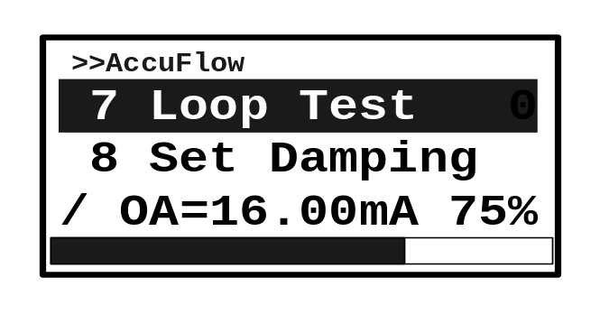（2）Press [Right]key to make the menu item "7 Loop Test" in focus;

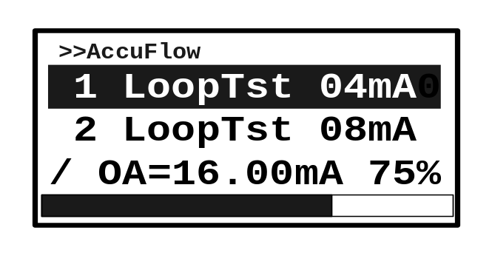（3）Press [MENU/OK] key to enter the loop test submenu；

Note: at this time the instrument output current is locked at 4mA.

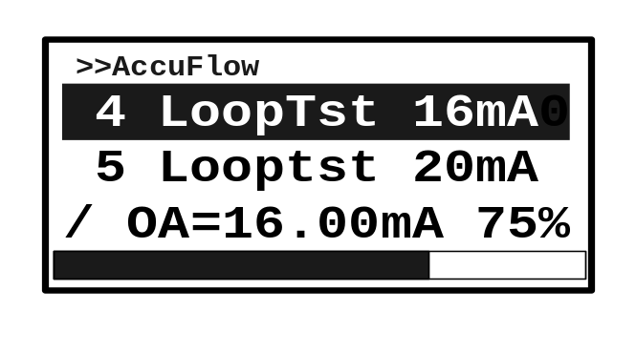（4）Press [Right] key, scroll menu item, can make the output current of the instrument locked to the corresponding value; (for example, the lock value is 16, as shown below)

Under the loop test menu status, press the [Left] key to exit the loop test and return to the previous menu, and the meter current returns to automatic.

3.3.9 Control mode conversion:
（1）Under [Monitoring value display status]Status, press [MENU/OK] key to enter [Menu Display Status]；

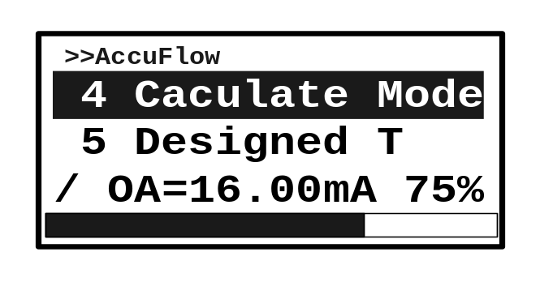（2）Press [MENU/OK]key ,enter flow setting sub-menu, press [right]key to make "4 Caculate Mode" in the focus state

（3）Press [MENU/OK] key to enter the submenu of operation mode selection；

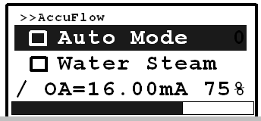

（4）Press [Right] key to scroll through the options. When “Analog Input” is selected, it is the external analog signal control mode; when “Local/RS485” is selected, it is local key operation control or RS485 communication control;
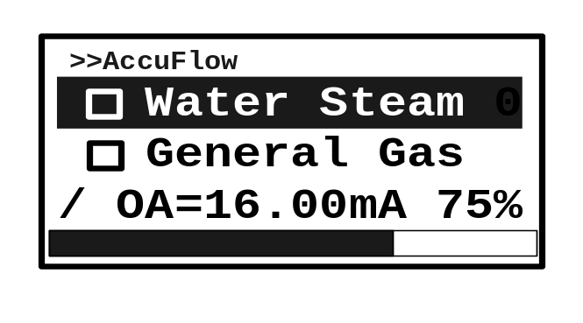

（5）At this point, press the [MENU/OK] key to enter the [Storage inquiry dialog box].

Press [left] key to store data, press [right] key, give up storage, and return to the previous menu. if stored, and the box before the selected item is filled with dot.

3.3.10 Set the output damping value:
（1）Under [Monitoring value display status]Status, press [MENU/OK] key to enter [Menu Display Status]；

（2）Press the [right]key to make the menu item "8 Set Damping" in focus.；
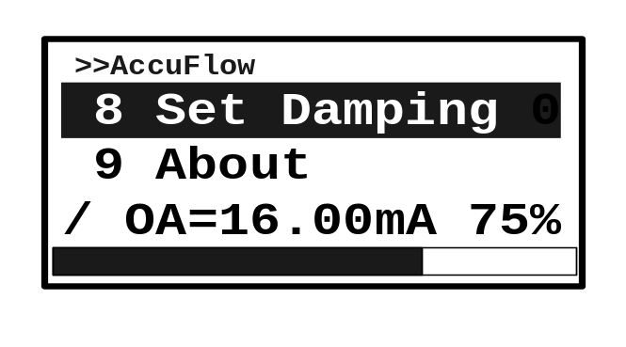

（3）Press [MENU/OK] key, will enter the damping setting submenu, and the third line shows the current damping value；
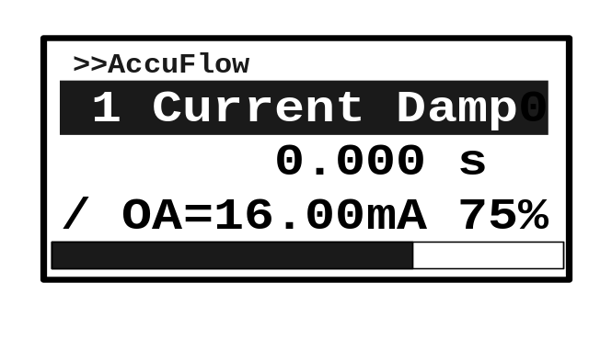

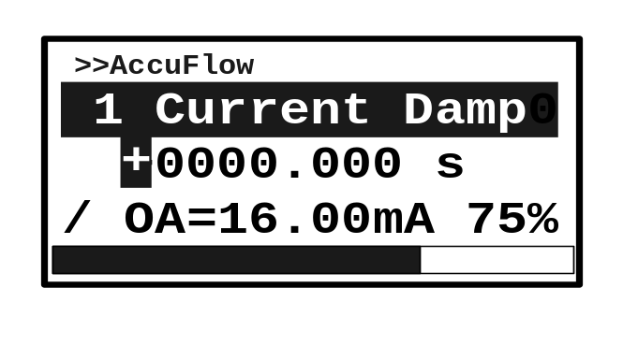（4）Press [MENU/OK] key to enter the [Parameter input dialog box], then enter the expected value (0~254)；

（5）After modifying the last character, press the [MENU/OK] key to enter the [Storage inquiry dialog box]；

At this point, press [left]key to store data, press [right] key, give up storage, and return to the previous menu.

